YD’s DataViz2: Annual Bonus Analysis

YD's DataViz

Find who will get the Annual Bonus using the P1-OfficeSupplies dataset.

Let’s Do It:

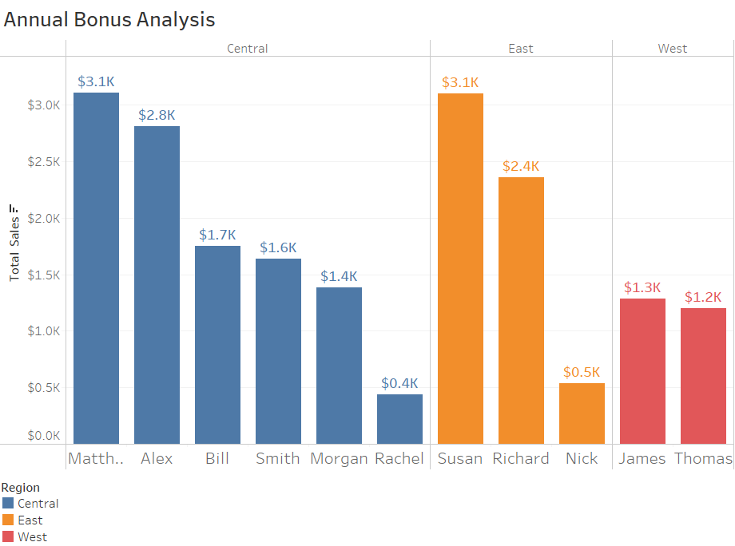

Thanks for reading till the end hope so you liked it leave your opinion about it in the comment section.